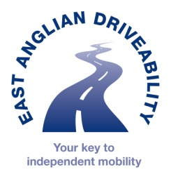
East Anglian DriveAbility
Unit 7 Wakes Hall Business Centre
Colchester Road
Wakes Colne
CO6 2DY
01787 222873

REFERRAL FORM
Assessment type |  | Charges that apply to client
Full fitness to drive assessment | ☐ | £210.00 + VAT / £170 with professional referral
Vehicle adaptations assessment | ☐ | £210.00 + VAT / £170 with professional referral
Vehicle access Driver/Passenger assessment | ☐ | £210.00 + VAT / £170 with professional referral
Scooter assessment | ☐ | No charge
Motorcycle assessment | ☐ | Available on request – please contact for pricing
Children’s car seat assessment | ☐ | £60 + VAT
Hubs Mobility service referral- for those no longer driving or lonely and isolated. | ☐ | No charge
Tuition for confidence building, adaptation training, or as part of rehabilitation | ☐ | £55 per hour
Choose an item.
Is the person aware of this referral?
POST CODE
Person’s Name: DoB

Address:

Tel: Mob:

Email:

Confirmed Diagnosis :

Date of Diagnosis or onset of illness:

Reason for referral:
Continue on separate sheet if needed
Does the person have a full UK driving licence?
Choose an item.

------------------------------------------------------------------------------------------------------------------------
Referrer information
Name Signature:
Position Location
Telephone nos Fax
Email
Date referral sent:

Please send referral to: mail@eastangliandriveability.org.uk

